**Yoga Pose Classification Model Performance**

The Yoga poses dataset : [dataset link](https://www.kaggle.com/datasets/niharika41298/yoga-poses-dataset), was trained on three different architectures for 20 epochs.

1. Vgg19
2. Mobilenet
3. ResNet50

Vgg 19 performance over the training period.

Training accuracy: 0.8285

Validation Accuracy: 0.9128

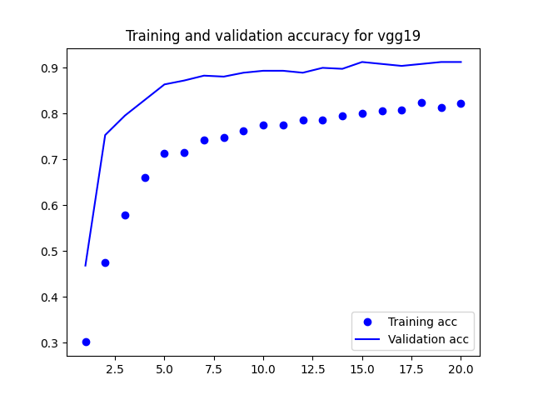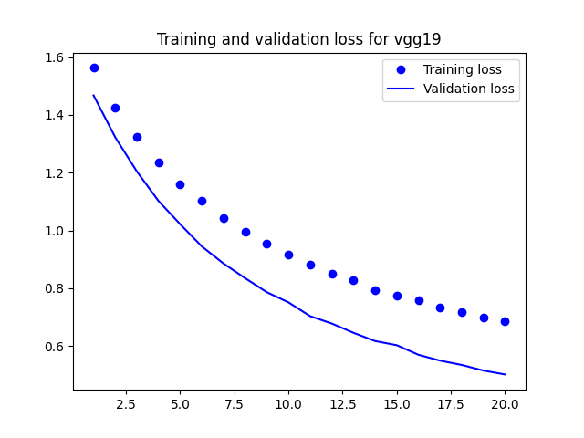

Mobilenet Performance over the training period:

Training Accuracy: 99.87

Validation Accuracy: 94.56

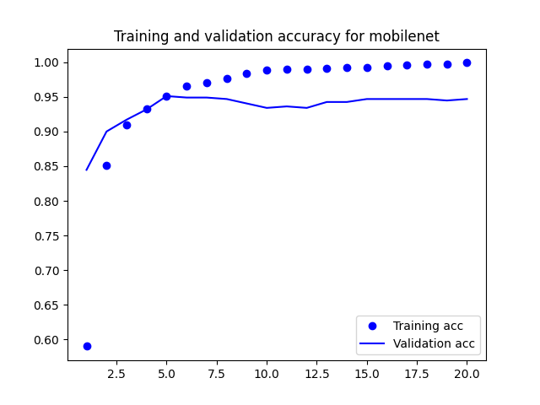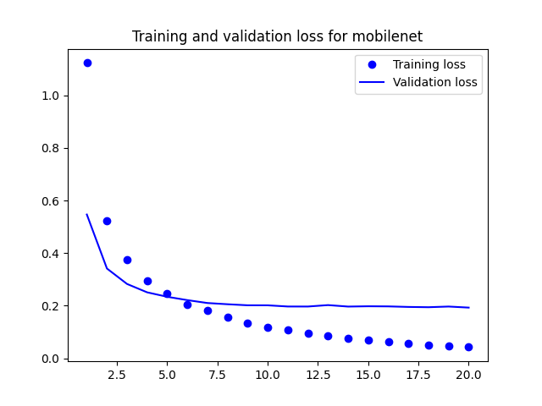

Resnet performance over the training period:

Training Accuracy: 99.89

Validation Accuracy: 95.12

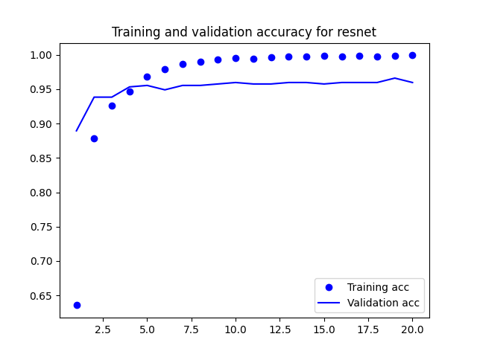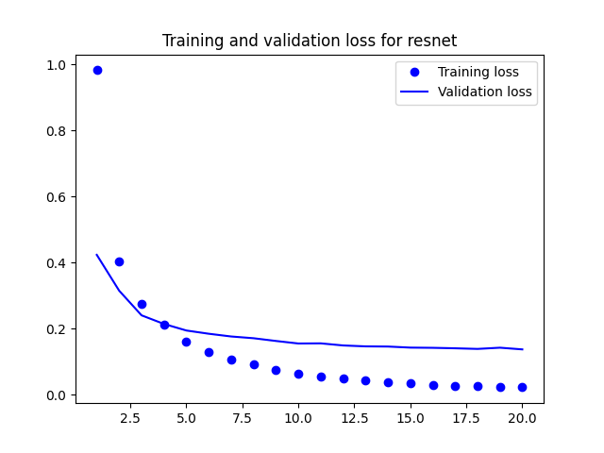

**Browser demo:**

